2.5 如何通过串口来进入管理页面
2.5.1 在PC上点击“开始”－“所有程序”－“附件”－“超级终端”
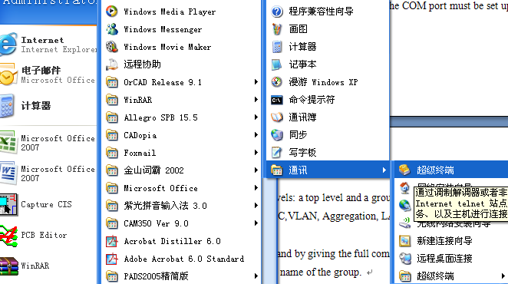
2.5.2 打开超级终端后，请选择使用“COM1”
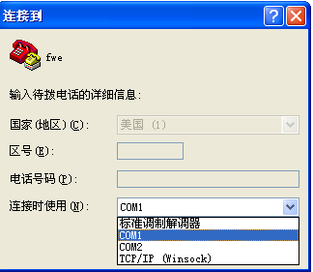
2.5.3 在COM1属性里，“每秒位数”请选择“115200”，“数据流控制”请选择“无”，点击“应用”、“确定”，然后回车即可。
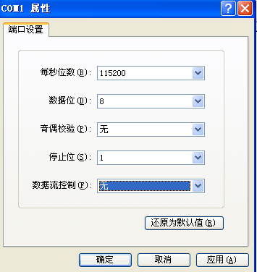
2.5.4 Example
The command hierarchy and the help utility is demonstrated in the following example:
> ? <enter>
Commands at top level:
System – System commands
Console – Console commands
Port – Port commands
MAC - MAC table commands
VLAN – VLAN commands
Aggregation – Aggregation/Trunking commands
LACP – IEEE802.3ad Link aggregation commands
RSTP – IEEE802.1w Rapid Spanning Tree commands
User Group – User Group commands
QoS – QoS commands
Mirror – Mirror commands
IP – IP commands
Dot1x – Dot1x commands
Debug - Debug commands
> console <enter>
Console> ? <enter>
Commands at Console level:
Console Configuration
Console Password [<password>]
Console Timeout [<timeout>]
Console Prompt [<prompt string>]
Console> password ?
Syntax:
Console Password [<password>]

Description:
Set or display console password. The empty string (“”) disables the password
check.

[<password>]: Password string of up to 16 characters.
Console>

